DEFINITION OF PERFORMANCE MANAGEMENT

Performance management is the process of continuous feedback and communication between managers and their employees to ensure the achievement of the strategic objectives of the organization.

IMPORTANCE of performance MANAGEMENT

The goal is to ensure that employees are performing efficiently throughout the year, and in the process, address any issues that may arise along the way that affect employee performance.

**Performance management supplements the annual**[**performance review**](https://www.hrtechnologist.com/articles/performance-management-hcm/the-absurdity-of-the-annual-performance-review/)**.** This prepares both employees and managers about what to expect during the annual appraisal. It keeps both the manager and the employee in the loop about ongoing changes to the performance management process, what both can do to streamline it, and how performance overall can be improved.

**To employees, continuous performance management indicates that managers value them**. Employees believe that their managers are interested in their work and care about their goals and any issues they may face in the course of their job. They also become more open to receiving constructive feedback

**The Performance Management Cycle**

The performance management process or cycle is a series of five key steps. These steps are imperative, regardless of how often you review employee performance.

**1. Planning**

This stage entails setting employees' goals and communicating these goals with them. While these goals should be disclosed in the job description to attract quality candidates, they should be communicated once again when the candidate becomes a new hire. Depending on the performance management process in your organization, you may want to assign a percentage to each of these goals to be able to evaluate their achievement.

**2. Monitoring**

In this phase, managers are required to monitor the employees’ performance on the goal. This is where continuous performance management comes into the picture. With the right performance management software, you can track your team’s performance in real-time and modify and correct course whenever required.

**3. Developing**

This phase includes using the data obtained during the monitoring phase to improve the performance of employees. It may require suggesting refresher courses, providing an assignment that helps them improve their knowledge and performance on the job, or altering the course of employee development to enhance performance or sustain excellence.

**4. Rating**

Each employee’s performance must be rated periodically and then at the time of the performance appraisal. Ratings are essential to identify the state of employee performance and implement changes accordingly. Both peers and managers can provide these ratings for 360-degree feedback.

**5. Rewarding**

Recognizing and rewarding good performance is essential to the performance management process, as well as an important part of [employee engagement](https://www.hrtechnologist.com/articles/employee-engagement/what-is-employee-engagement/). You can do this with a simple thank you, social recognition, or a full-scale employee rewards program that regularly recognizes and rewards excellent performance in the organization

**Performance Management Best Practices**

The only way to ensure the success of performance management is to treat it like a continuously evolving, fluid process by three best practices.

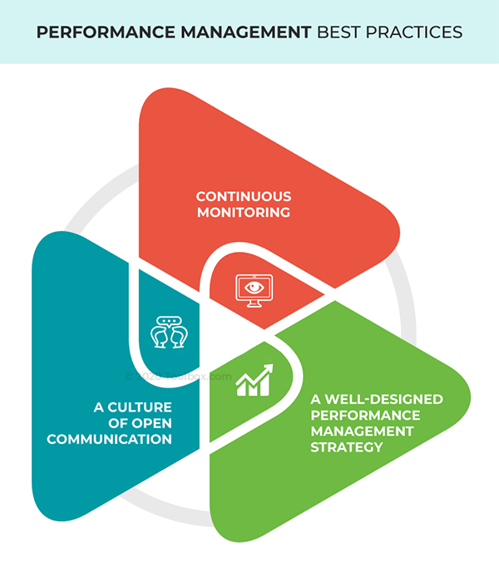

**Fig 1. Best Practices for Effective Performance Management**

**1. A well-designed performance management strategy**

Some of the key questions that a well-designed performance management plan will answer are:

* How often will employee performance be evaluated – weekly, monthly, or quarterly?
* What systems are in place for this evaluation – sentiment analysis trackers, automated pulse surveys, one-on-one meetings?
* What approach will a feedback conversation follow?
* What will the post-feedback approach and evaluation system be?

To this, Enderes and Shannon add, “Small bite-sized feedback that is provided by the people closest to the work, in the flow of work, and with actionable input helps make steady improvements and enables learning in the flow of work.”

This again is made possible by using an automated performance management tool that allows you to set goals, modify them, and communicate changes on the go. No unnecessary meetings are required, and employees can modify their work plan and strategy as per the goals you assign

**2. A culture of open and effective communication**

Continuous monitoring can help initiate conversations about employee issues. A negative sentiment or the poor performance of an employee can be addressed only when communication is open and transparent in an organization.

A culture of communication is an organization-wide responsibility, starting from top leadership and trickling down to all departments. Managers will adopt this culture and deliver honest feedback to employees, allow employees to be honest, and use that information to help them.

A culture of communication is also developed by hiring people managers who are skilled in delivering both positive and constructive feedback – managers who motivate employees but also hold them accountable for their work.

Transparent communication also includes:

* Sharing with the employee exactly what is expected of them.
* Coaching employees to reach their maximum potential through actionable goals.
* Giving them actionable, not generic, feedback.
* Revealing the rewards in place for successful goal achievement.

**3. Continuous monitoring**

This may sound more like a “Big Brother” form of monitoring an employee’s every move and action, but that is the exact opposite of efficient performance management.

In the HR context, this involves tracking employees' progress in real-time and monitoring the output and outcomes an employee delivers. Also, by keeping an eye on employee sentiment, through observation, interactions, as well as with the help of [sentiment analysis tools](https://www.hrtechnologist.com/articles/employee-engagement/sentiment-analytics-tools-features-price/), managers can assess the general mood of their teams. This allows them to address the specific problem at hand as soon as a problem occurs.

With the tech tools available, as discussed in detail later, continuous monitoring at a granular level is now a much easier task. And with the objective data an automated performance management software can reveal, it is easier to start conversations with employees.

To enable all these elements of a successful performance management strategy, there is a host of automated performance management systems to choose from. These solutions can simplify several operations that traditionally relied on manual processes as well as monitoring and feedback delivery.